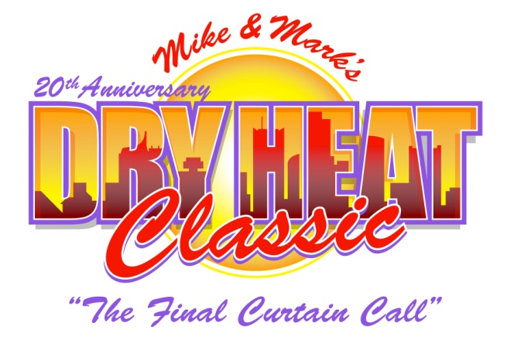
Golfer's Entry Form

20th Annual Dry Heat Classic • July 20, 21, & 22, 2017

Pointe Hilton Tapatio Cliffs Resort
11111 North 7th Street
Phoenix, AZ 85020
Phone: (602) 866-7500
www.TapatioCliffsHilton.com

For Reservations Call: 1-800-445-8667
Ask for Dry Heat Room Rate: $87.59 per night all-inclusive (Use Event Code: DBC)
Yes! Please register me for this year’s golf tournament as follows (Entry Deadline: June 19th):

Single Golfer(s) @ $600.00 per player (includes 2 Dinner/Auction Tickets & 2 Comedy Variety Show Tickets)
Golfers: # (Please list names in box below) @ $600 per player = Amt: $

Corporate Sponsorship Category: Amt: $

I cannot play, please accept my donation (please indicate amount to right) Amt: $

Extra Thursday - Dinner / Auction Ticket(s): # @ $65.00 each Amt: $

Total $:
Please make checks payable to: Michael Finney Foundation

MasterCard / VISA / AMEX: Account #
Exp. Date: V Code: Phone:
Name on Card (please print):
Address: City: State: Zip:
Signature: Date:

Name (player #1) Cell Ph Shirt Size
Address: City: State: Zip:
Email: Spouse / Guest attending? Y N
Name (player #2) Cell Ph Shirt Size
Address: City: State: Zip:
Email: Spouse / Guest attending? Y N
Name (player #3) Cell Ph Shirt Size
Address: City: State: Zip:
Email: Spouse / Guest attending? Y N
Name (player #4) Cell Ph Shirt Size
Address: City: State: Zip:
Email: Spouse / Guest attending? Y N

Please Return To: Annual Dry Heat Classic ▪ 7220 W. Melinda Lane ▪ Glendale AZ 85308
P (623) 581-2537 ▪ F (623)-376-6547 ▪ email: FinneyGolf@aol.com
The Michael Finney Foundation is a 501c3 #86-0954575 Organization
www.dryheatclassic.org

